**Software Design**

**Project:** A Food Waste Reduction Website

**Team:** **Ninja Cat Coder**

**Revision History**

|  |  |  |  |
| --- | --- | --- | --- |
| Date | Version | Description | Author |
| 02/12/2024 | 1.0 | I came up with a comprehensive class diagram for my Food Waste Reduction Website. | Tobi Adeoye |
| 02/12/2024 | 2.0 | I came up with a diagram for the class diagram section. | Tobi Adeoye |
| 02/12/2024 | 3.0 | I have created a well-organized diagram for the Entity-Relationship (ER) Diagram. | Tobi Adeoye |
| 02/12/2024 | 4.0 | I have started to create a well-organized Sequence Diagram for the user registration and login sections. | Tobi Adeoye |
| 02/13/2024 | 5.0 | I have started to create a well-organized Sequence Diagram for the Geolocation Services, User Dashboard and Surplus Food Listings sections. | Tobi Adeoye |
| 02/14/2024 | 6.0 | I have created a well-organized Information Architecture Diagram for my project. | Tobi Adeoye |
| 02/15/2024 | 7.0 | I have come up with a good color palette, logo, and Stylesheet for my User Interface Wireframe. | Tobi Adeoye |
| 02/16/2024 | 8.0 | I came up with the User Interface Design for my login and User Registration. | Tobi Adeoye |
| 02/17/2024 | 9.0 | I came up with the User Interface Design for my user dashboard and my Geolocation Services . | Tobi Adeoye |
| 02/18/2024 | 10.0 | I came up with the User Interface Design for my Surplus Food Listings. | Tobi Adeoye |
| 02/06/2024 | 11.0 | I came up with a comprehensive Design Rationale for my project. | Tobi Adeoye |

**Class Diagram**

1. **User:** This class represents a user of the Food Waste Reduction Website. It includes information such as the user's full name, email address, password, and user type (surplus provider, recipient, etc.). Users have the ability to create surplus food listings and make requests to receive surplus food as recipients.
2. **Surplus Food Listing:** This class represents a listing of surplus food available for donation. It includes information such as listingId, foodType, quantity, expirationDate, and pickupLocation. Surplus food listings are created by users (surplus food providers) and can be requested by recipients.
3. **Recipient Request:** This class represents a request made by a recipient for a specific surplus food listing. This class will have a requestId, recipient, listing, and status(e.g., pending, accepted, declined). Recipient requests are initiated by recipients interested in obtaining surplus food donations.
4. **Location:** This class represents a geographical location with latitude and longitude coordinates. This class will have a locationId, Latitude, longitude. This class is associated with surplus food listings to indicate pickup locations.
5. **User Dashboard:** This class represents a user dashboard feature of the Food Waste Reduction Website. This class will have a user, surplusListings, requests for identification. The user dashboard provides users with a centralized view of their surplus food listings and recipient requests, allowing them to manage and track their donations efficiently.

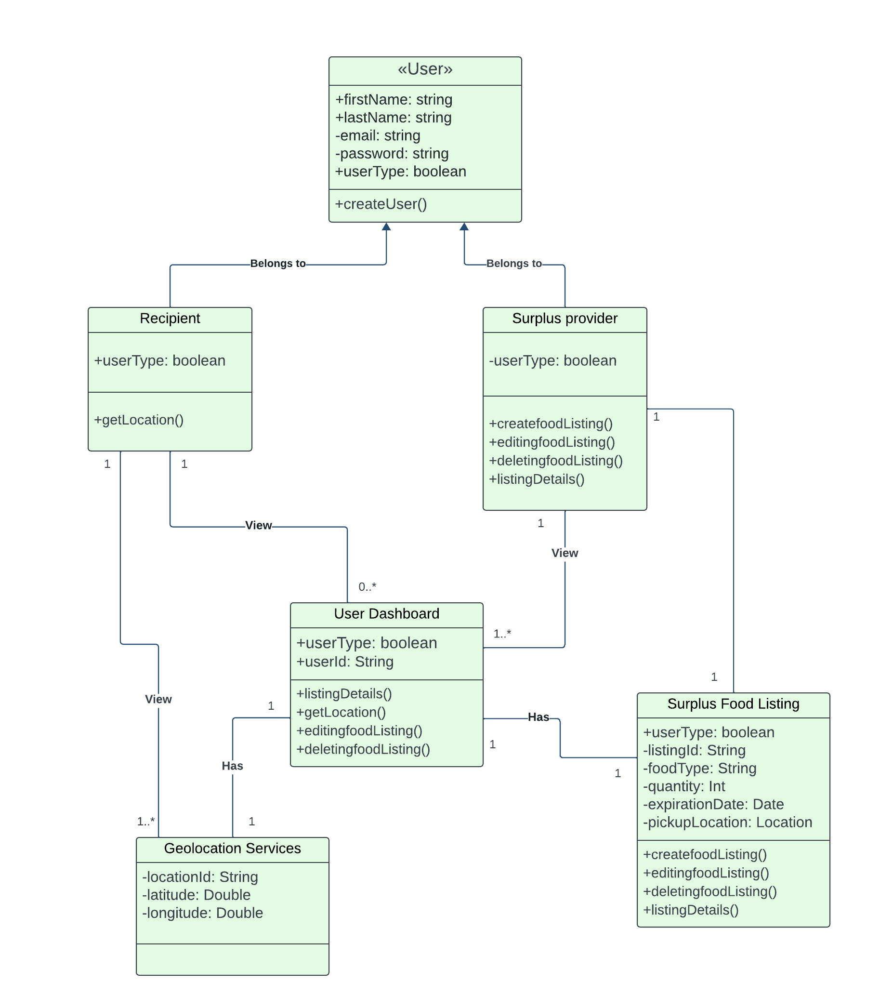

**ER Diagram(s)**

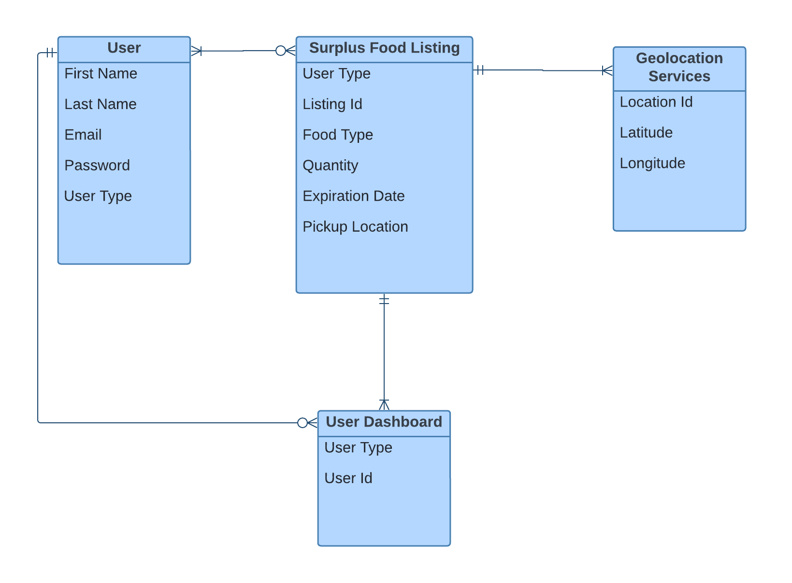

**Sequence Diagram(s)**

1. **User Registration**

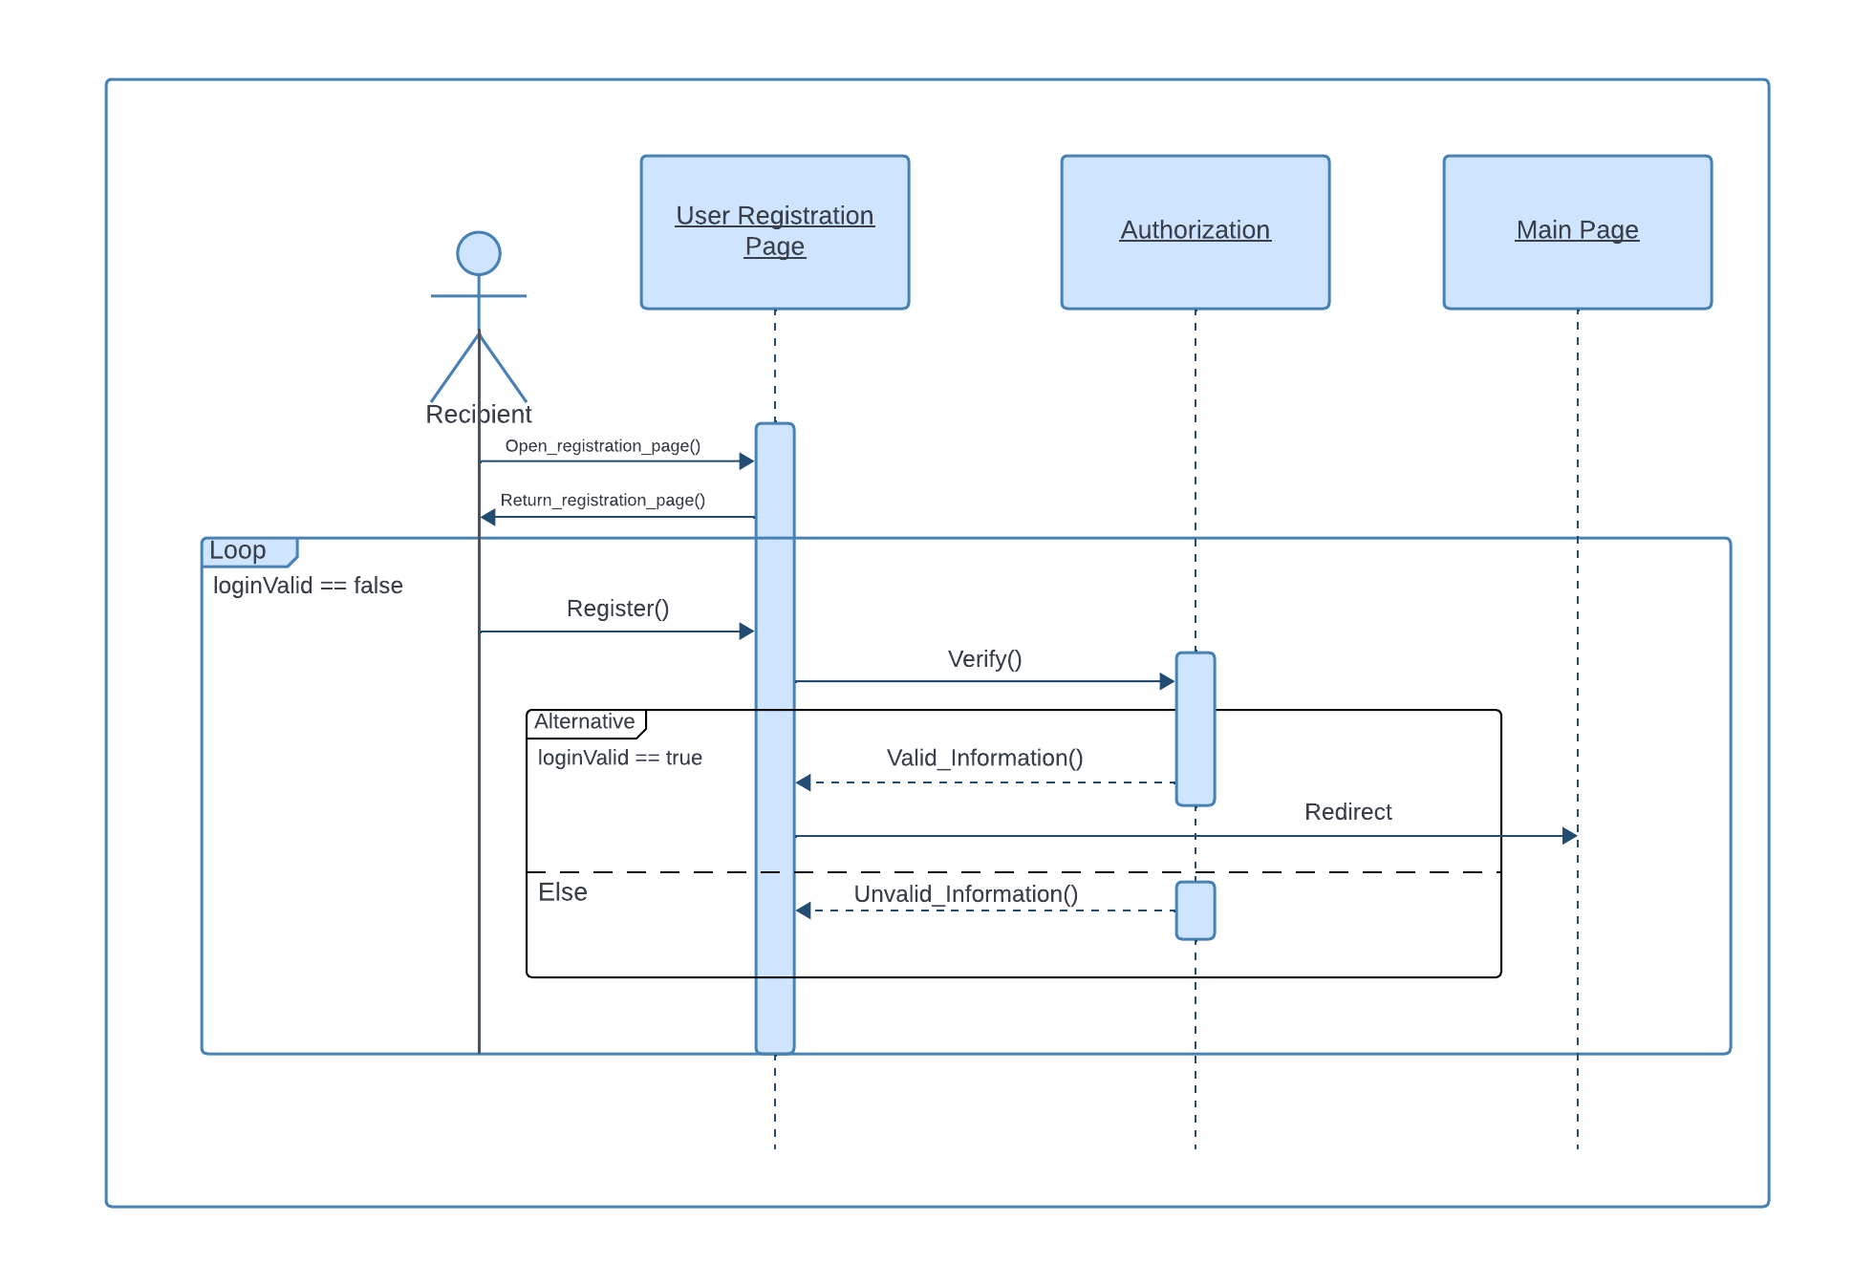

**2.** **Login**

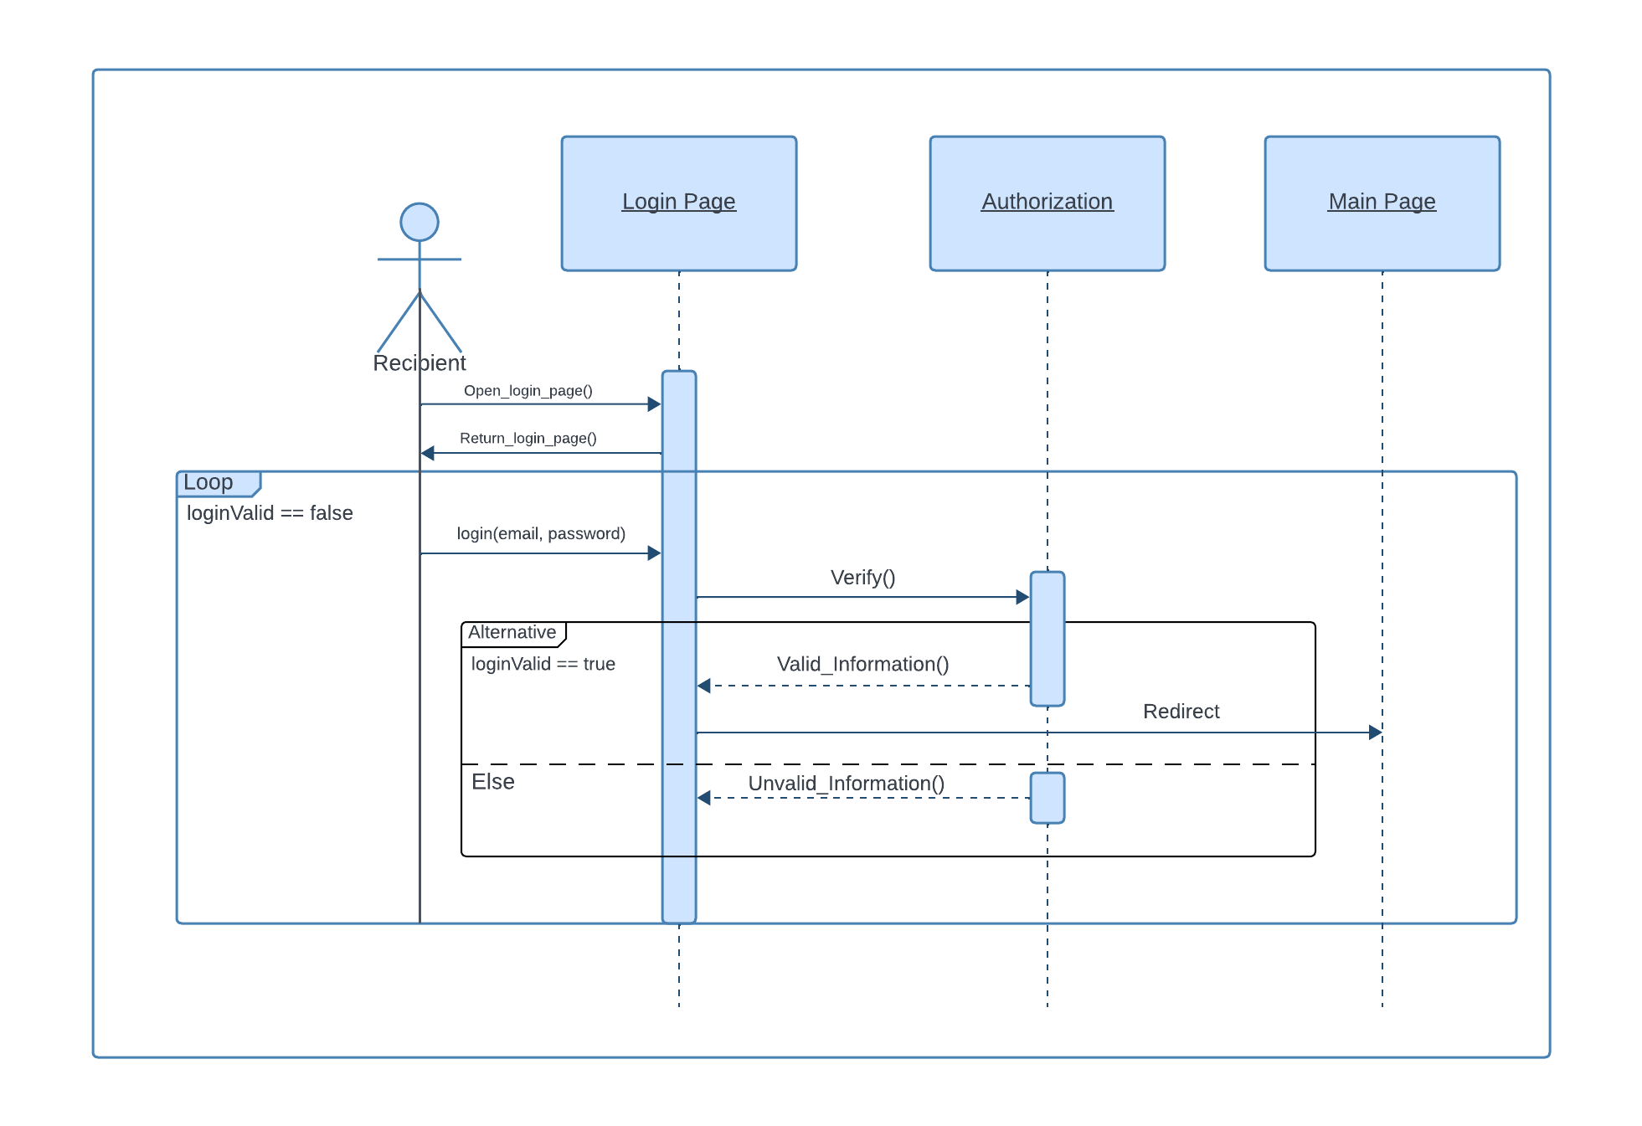

**3.** **Surplus Food Listings**

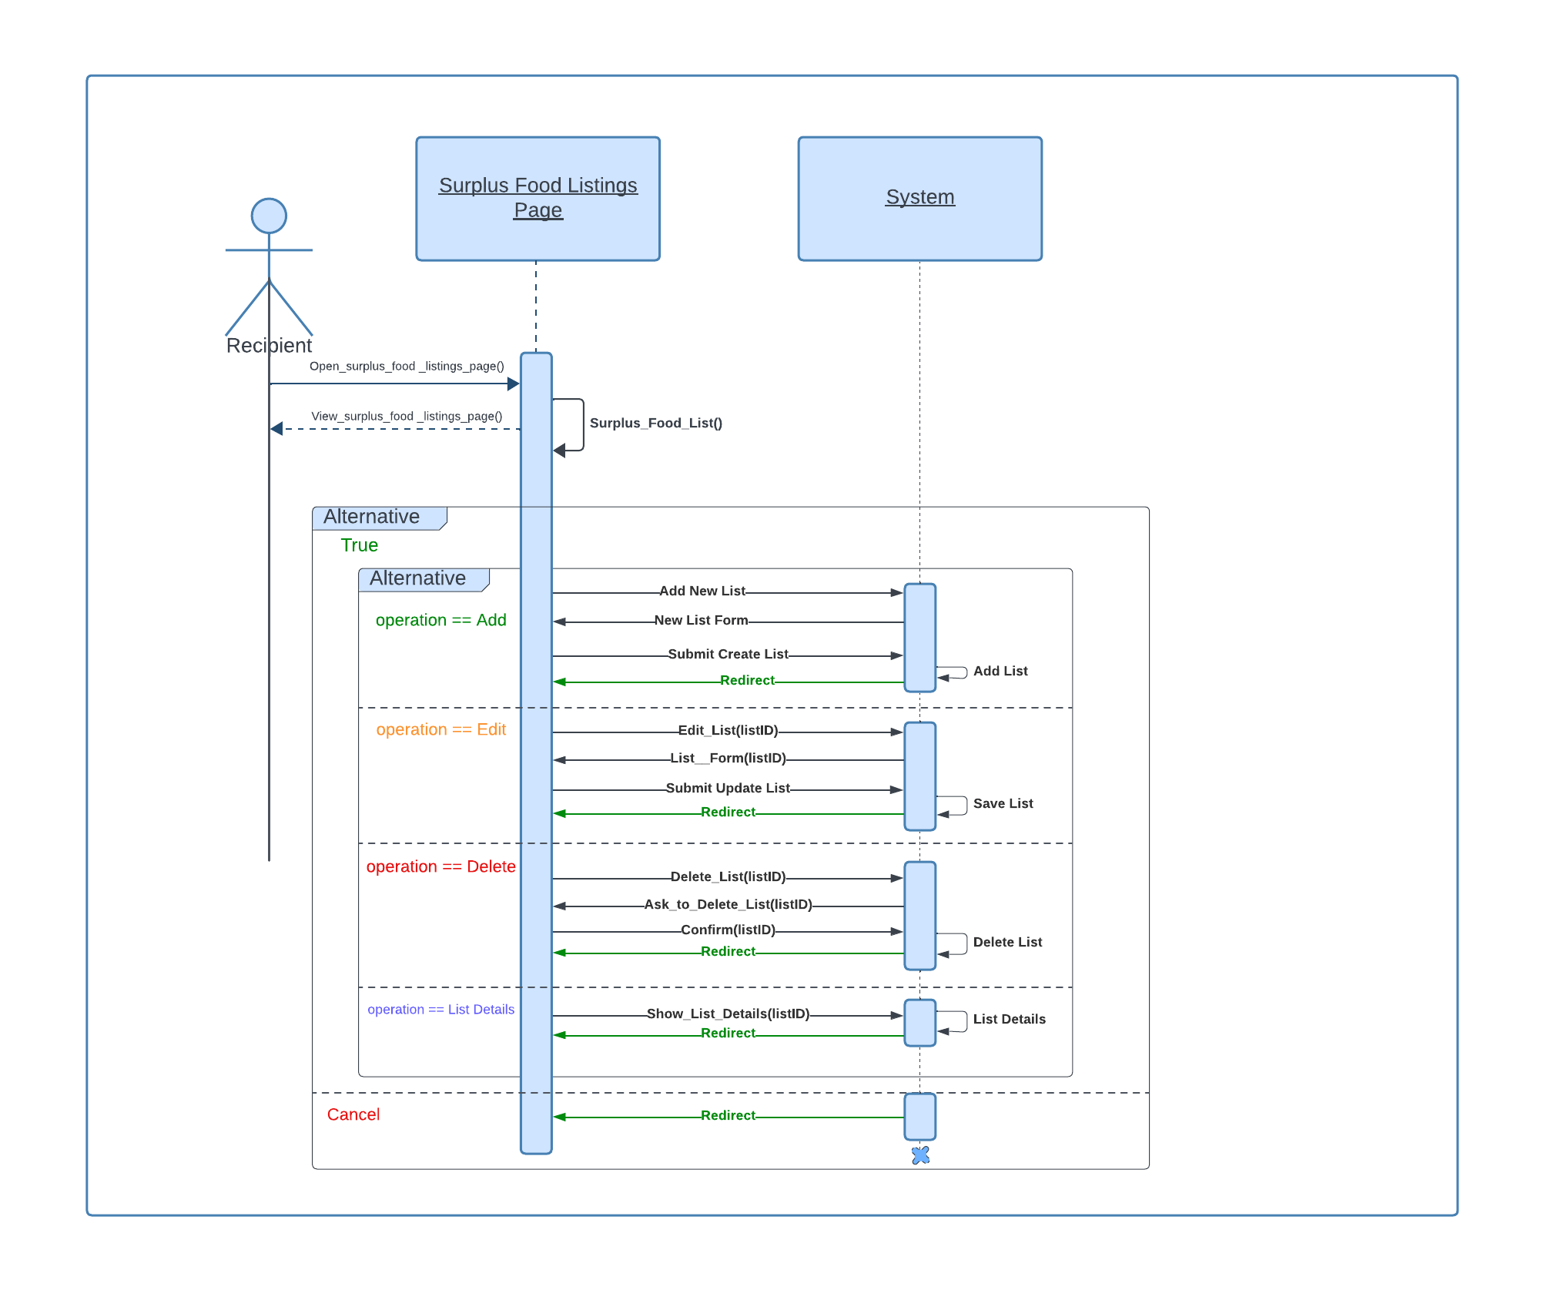

**4.** **Geolocation Services**

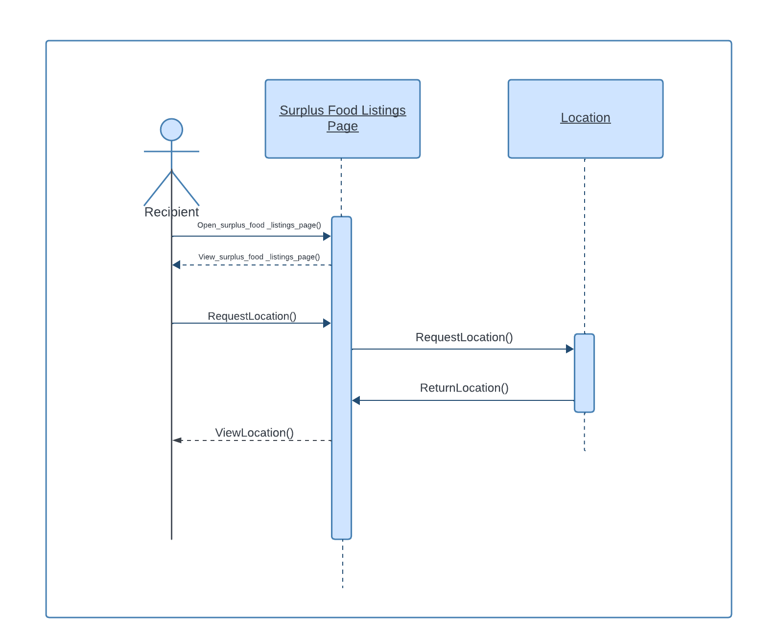

**5.** **User Dashboard**

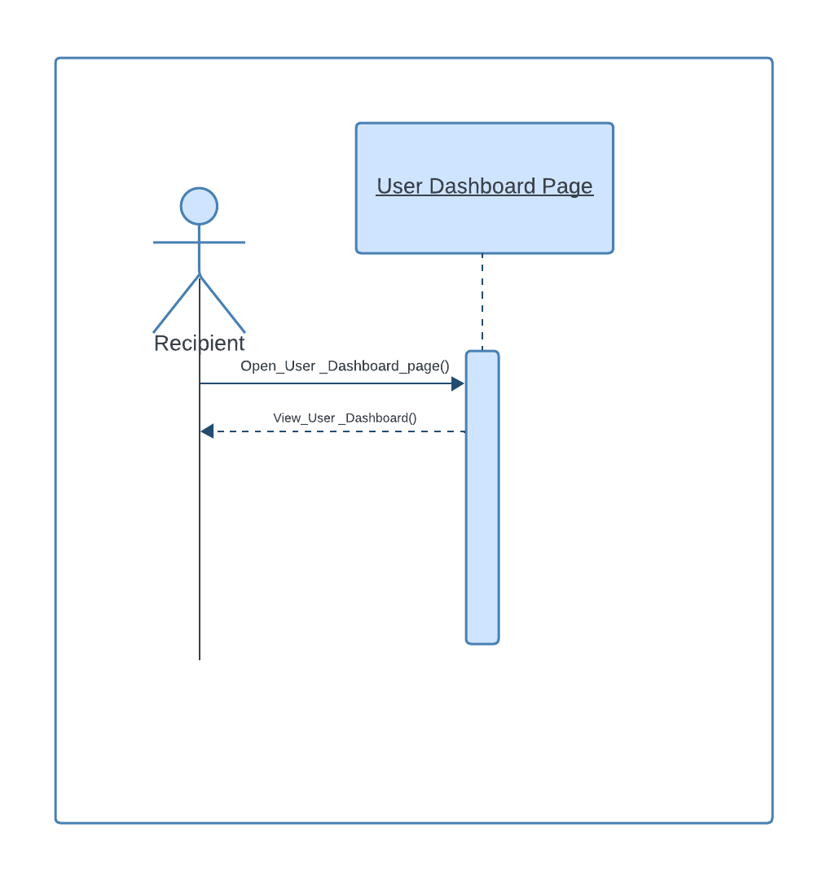

**Information Architecture Diagram**

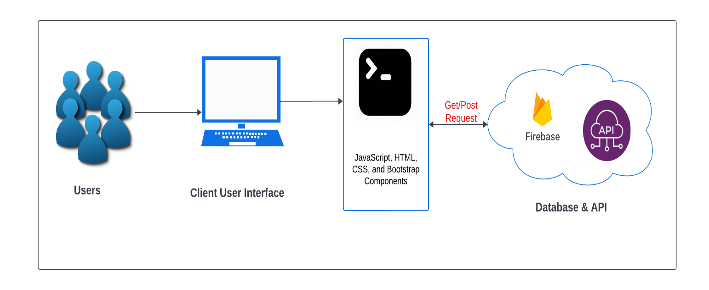

**Design Rationale**

**Classes and Entities**

The core classes like User, Surplus Food Listing, Recipient Request, and Location were chosen to encapsulate the fundamental entities of the food donation and distribution process. The User class facilitates different roles within the system, such as donors, recipients, and administrators, ensuring flexibility and scalability. Surplus Food Listings and Recipient Requests are central to the application's objective of reducing food waste, designed to match surplus food with those in need efficiently.

Location Class: Provides the ability to map accurately and match donations and their equated recipients within the locale, thereby reducing food wastage and ensuring logistics optimization.

**Relationships**

A One-to-Many Relationship between the Users and Listings/Requests: It represents a real-world scenario where one user can list a number of food items and request a number of times, thus keeping the system dynamic and flexible.

Many-to-Many Relationship between Listings and Recipients—Caters for the eventuality of one listing going to many recipients and also that a recipient may get a listing from many donors, thus maximizing the possible reduction of food waste.

The relationships between entities were carefully designed to reflect real-world interactions within the food donation ecosystem. For instance, the relationship between Surplus Food Listings and Recipient Requests allows for an efficient matching process, facilitating the primary goal of reducing food waste. The use of foreign keys and relational integrity constraints ensures data consistency and integrity across the system.

**User Interface Design**

Wireframe and Color Palette: A reflection of the user experience being at the core of this site design ensures ease of navigation and access for all. The color palette chosen maintains the sense of community and sustainability underpinning this project's ethos.

Bootstrap Framework: Utilized for responsive design, ensuring the website is accessible across various devices, crucial for reaching a broad user base.

**User Interface Wireframe(s)/Screenshot(s)**

* **Color**

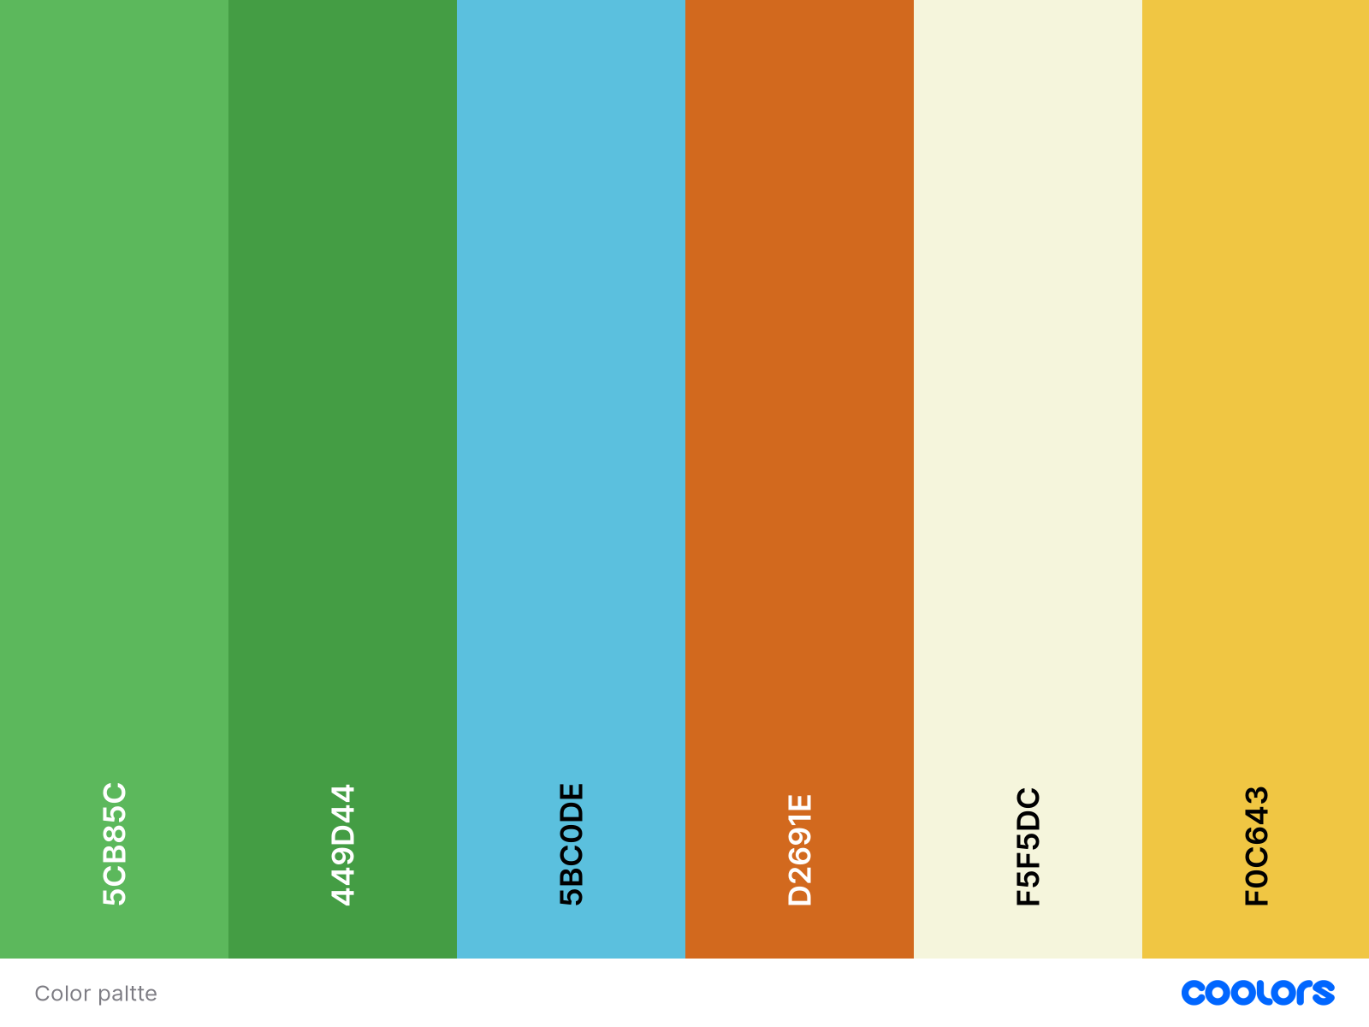

* **Stylesheet**

We are going to use Bootstrap to style the UI.

* **Logo**



1. **User Registration**

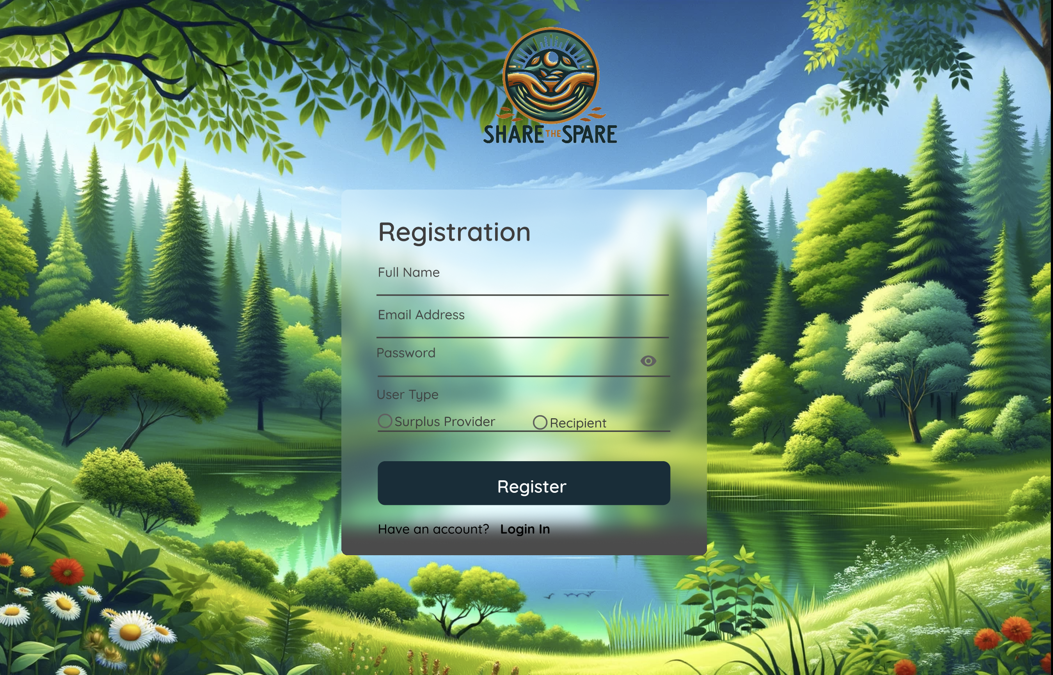

1. **Login**

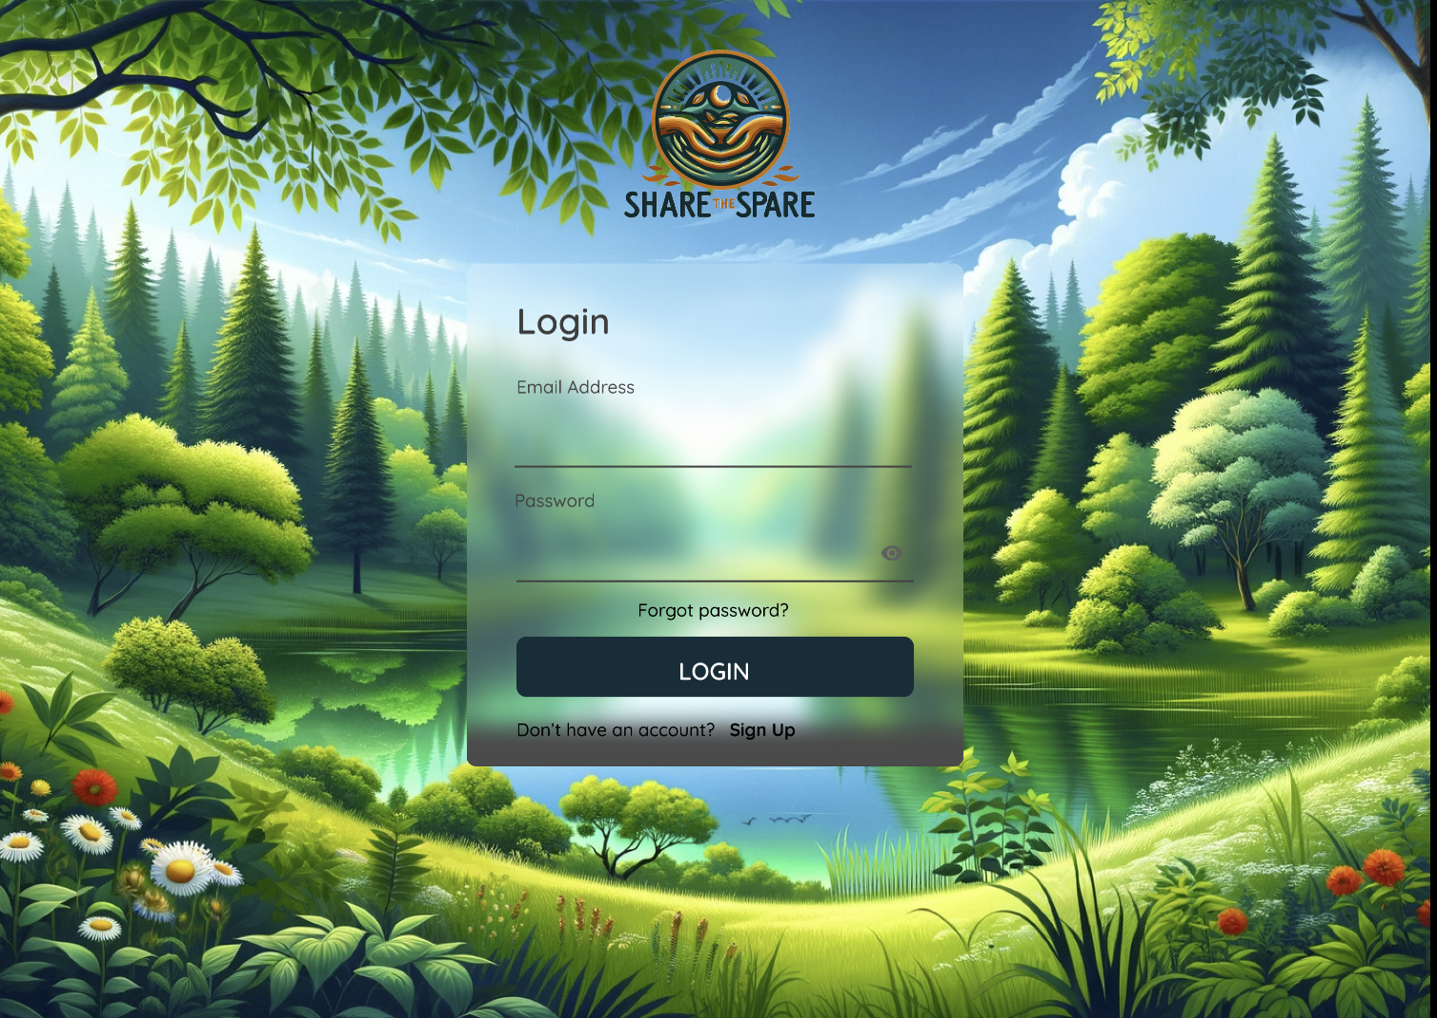

1. **Surplus Food Listings**

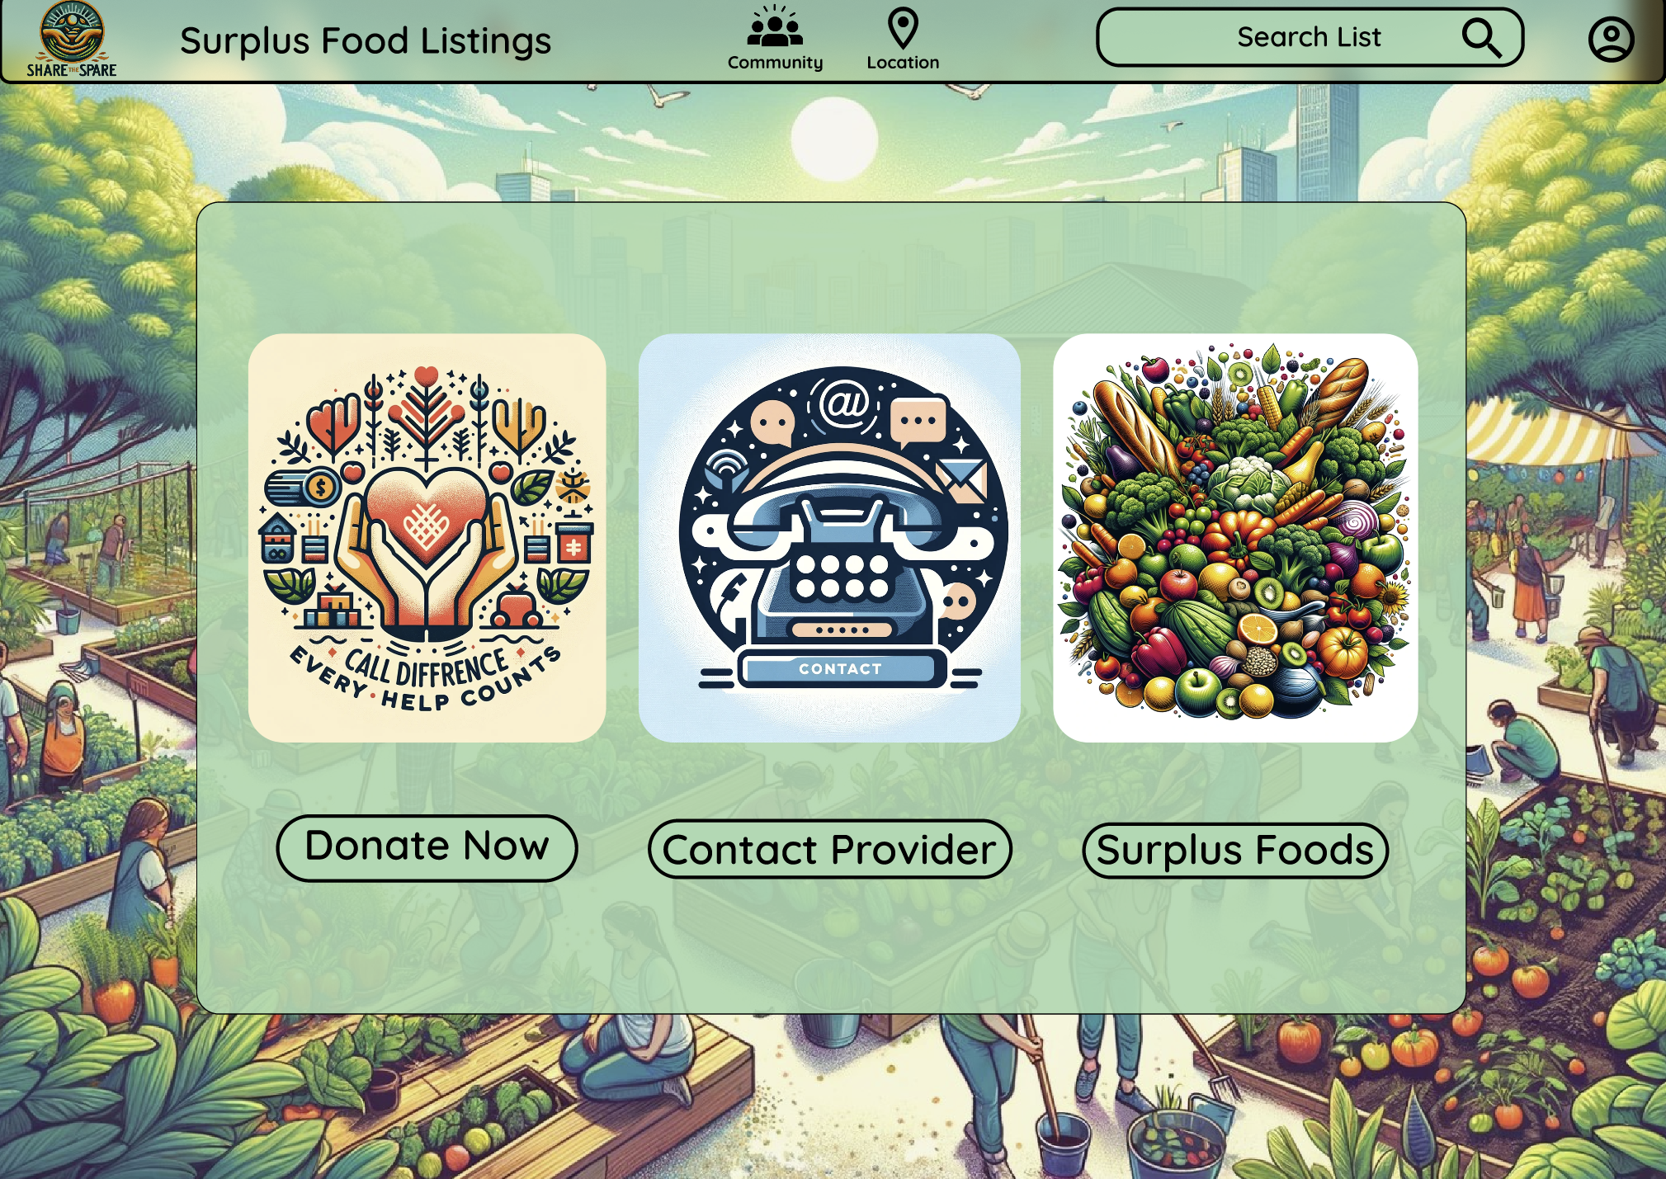

1. **Geolocation Services**

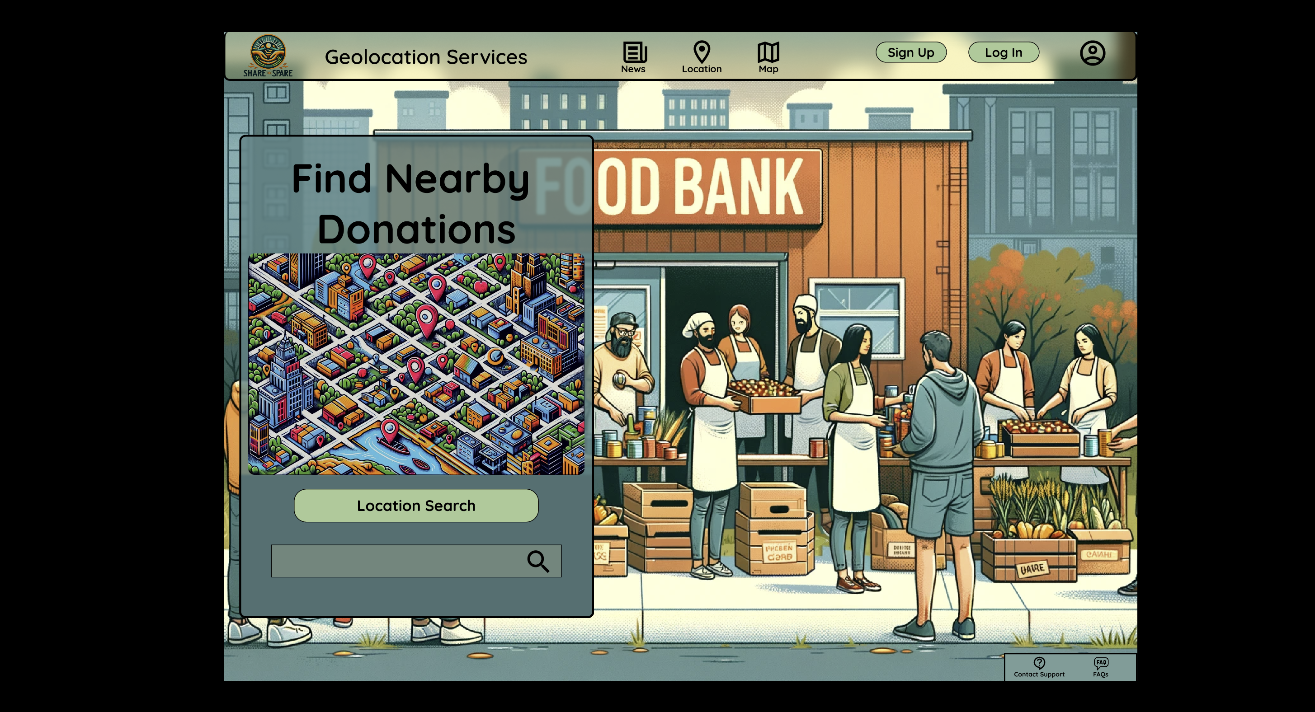

1. **User Dashboard**

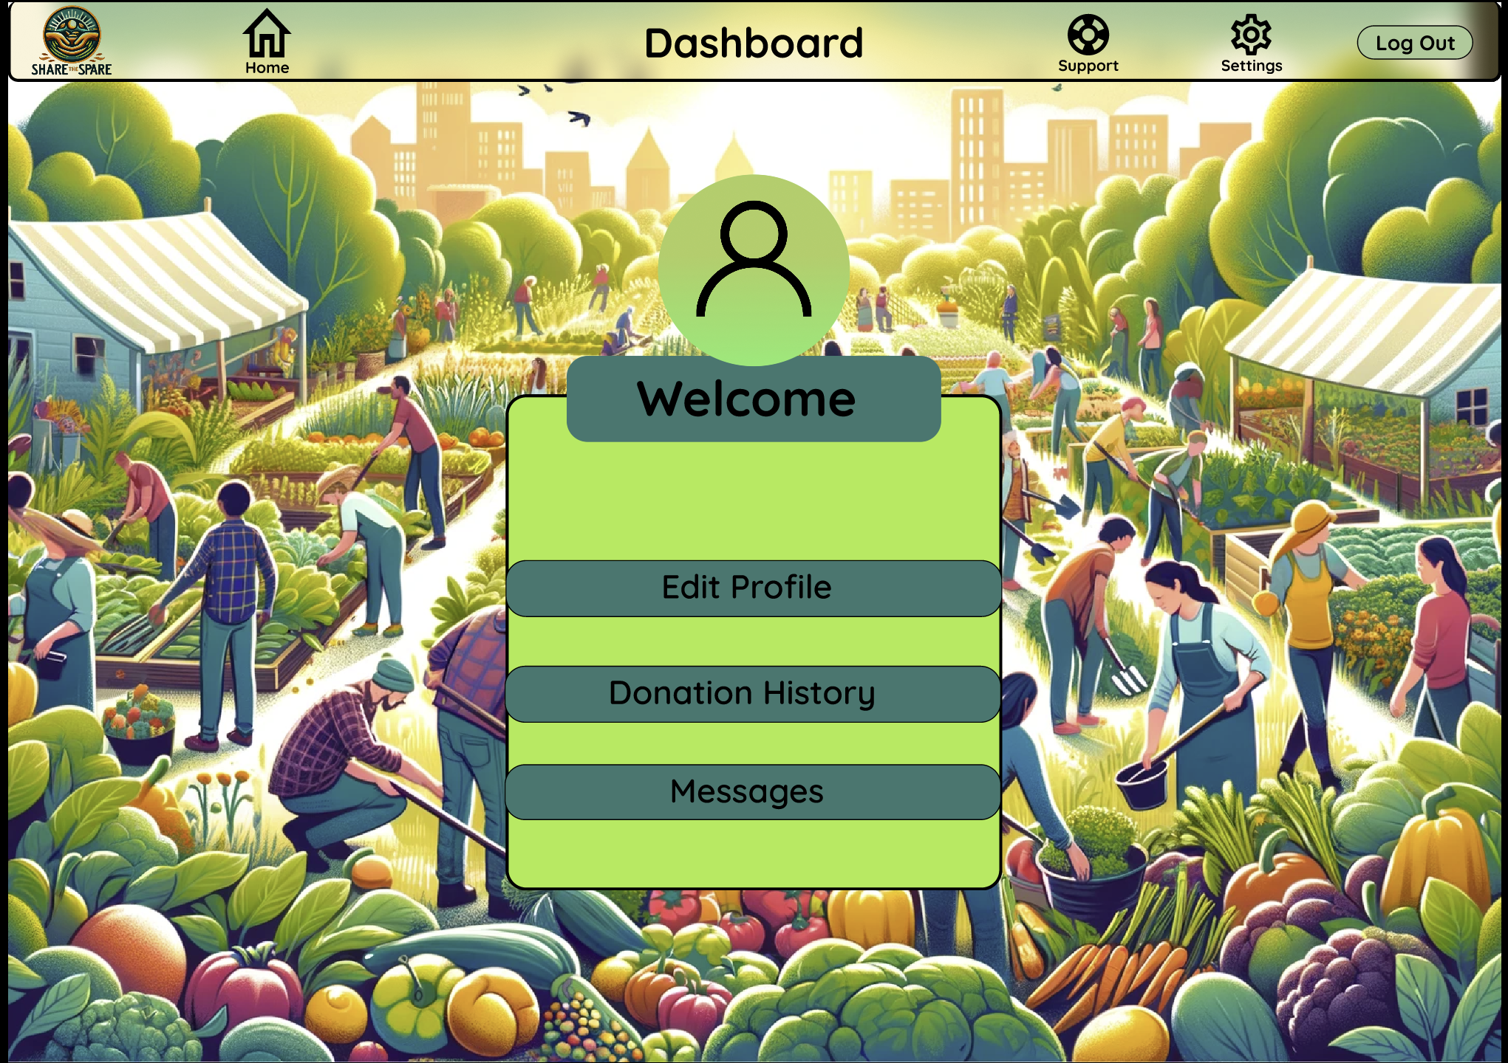

**Individual Contributions**

|  |  |  |
| --- | --- | --- |
| Name | Student ID | Description |
| Tobi Adeoye | 11483688 | I came up with a comprehensive class diagram for my Food Waste Reduction Website. |
| Tobi Adeoye | 11483688 | I created a well-organized diagram for the Entity-Relationship (ER) Diagram. |
| Tobi Adeoye | 11483688 | I created a well-organized Sequence Diagram for my Food Waste Reduction Website. |
| Tobi Adeoye | 11483688 | I created a well-organized Information Architecture Diagram for my project. |
| Tobi Adeoye | 11483688 | I created a well-organized Sequence Diagram for the Geolocation Services, User Dashboard and Surplus Food Listings sections. |
| Tobi Adeoye | 11483688 | I created a comprehensive Design Rationale for my project. |
| Tobi Adeoye | 11483688 | I create a good User Interface Wireframe for my project. |